1. There are five grant type flows in Oauth.
2. Based on our security requirements, we select one of them.
3. When we say grant flow or Oauth flow, that means these are the flows that authorization server, client, resource servers follow in order to generate tokens, validate tokens and interact with each other.
4. 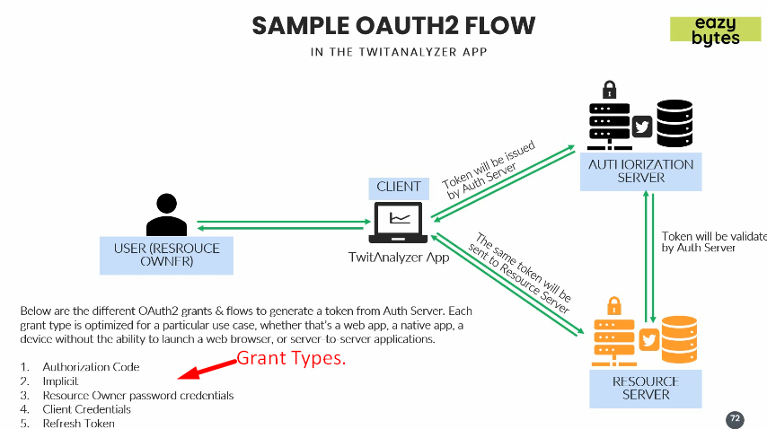 Let’s see the first Grant Type 🡺 Authorization Code
5. **Authorization Code** 🡸 Grant Type: Following is the high level view of the flow in Authorization Code Grant Type.
   1. This is very similar what we saw in Stackoverflow web site in last lecture.
   2. 